1. Key UML Diagrams in different phases of projects
- Inception Phase
  - Business Modeling
    - Activity Diagram
- Elaboration Phase
  - Requirements
    - Use Case
  - Analysis & Design
    - Object/Class Diagram
    - Interaction Diagram
      - Collaboration
      - Sequence
    - State Chart

- Construction Phase
- Transition Phase

z

The modern approach, strongly supported by the UML is to forget all about objects
and classes at the early stages of a project, and instead concentrate on what the system
must be able to do. Then, as the project progresses, classes are gradually built to
realise the required system functionality. Through this course, we will follow these
steps from the initial analysis, all the way through to class design.

The first thing to notice about the UML is that there are a lot of different diagrams
(models) to get used to. The reason for this is that it is possible to look at a system
from many different viewpoints. A software development will have many
stakeholders playing a part . for example:
 Analysts
 The Customer
 Technical Authors
All of these people are interested in different aspects of the system, and each of them
require a different level of detail
Collaboration Diagrams
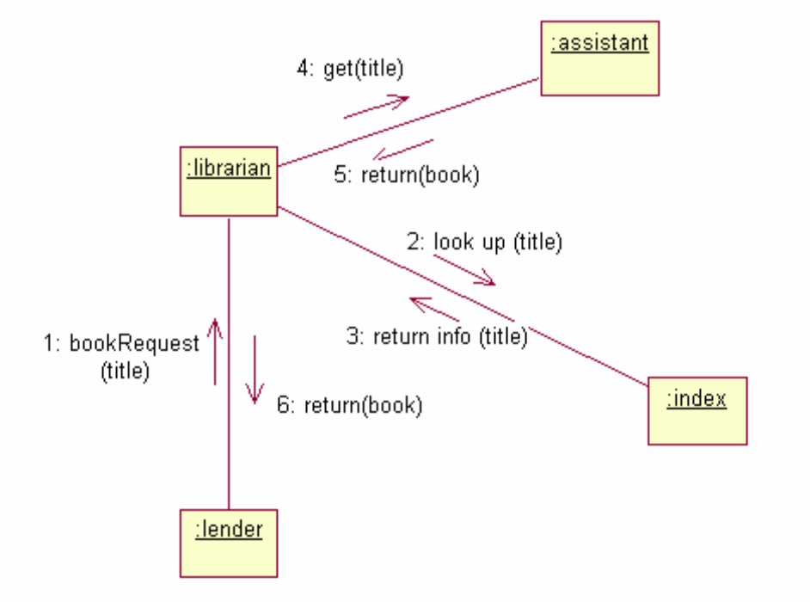
Figure 15 - The UML Collaboration Diagram
As we are developing object-oriented software, anything our software needs to do is
going to be achieved by objects collaborating. We can draw a collaboration
diagram to describe how we want the objects we build to collaborate.
Here is a good example of why the UML is .just. a syntax rather a true software
development process. We will see that the UML notation for the diagram is simple
enough, but designing effective collaborations, (that is to say .designing software
which is easy to maintain and robust.), is very difficult indeed. We shall be devoting
an entire chapter for guidelines on good design principles, but much of the skill in
design comes from experience.
Sequence Diagram
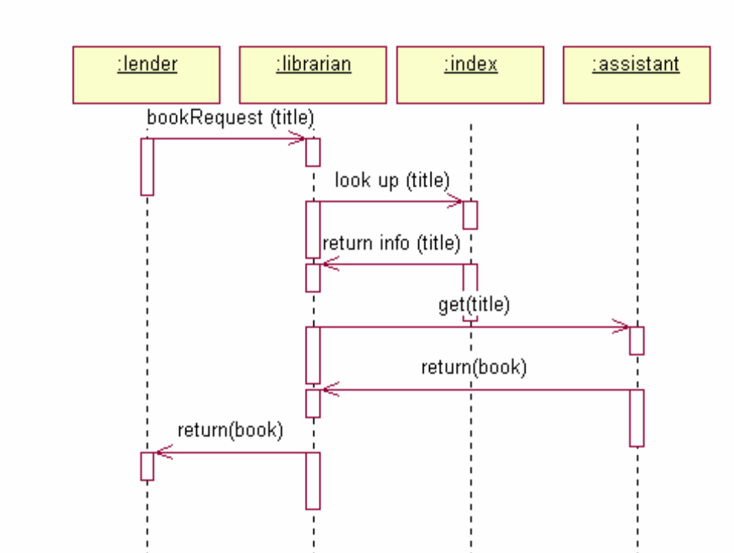
Figure 16 - A UML Sequence Diagram
The sequence diagram is, in fact, directly related to the collaboration diagram and
displays the same information, but in a slightly different form. The dotted lines down
the diagram indicate time, so what we can see here is a description of how the objects
in our system interact over time.
Some of the UML modelling tools, such as Rational Rose, can generate the sequence
diagram automatically from the collaboration diagram, and in fact that is exactly how
the diagram above was drawn . directly from the diagram in Figure 15.

An actor could also possibly be a more abstract concept such as time, or a specific date. For
example, we may have a use case called .Purge Old Orders. in an order processing
system, and the initiating actor could be .Last Working Day..
1. Requirements Phase

1.1 Use Case

- Use Cases define the scope of the System. They enable us to visualise size and scope of the entire development.
- Use Cases are very similar to requirements, but whilst requirements tend to be vague, confusing, ambiguous and poorly written, the tighter structure of
- Use Cases tend to make them far more focused The .sum. of the use cases is the whole system. That means that anything not covered by a use case is outside the boundary of the system we are developing. So the Use Case diagram is complete, with no holes.
- They allow for communication between the customer and developers (since the diagram is so simple, anyone can understand it)
- Use Cases guide the development teams through the development process . weshall see that Use Cases are the backbone of our development, and we refer to them in everything we do. We.ll see that Use Cases provide a method for planning our development work, and allow us to estimate how long the development will take
- Use Cases provide the basis for creating system tests
- Finally, Use Cases help with the creation of user guides!

It is often claimed that Use Cases are simply an expression of the system requirements. Anyone making this claim are clearly missing the point of Use Cases.

1.1.1 Guide Lines for drawing Use Case in Requirements Phase
- No technical terms such as Array, Variable, datatypes or database to be used. These terms could only be used during design phase. Only captured all the terms that the customer’s recognizes.

- A Use Case should satisfy a goal for the actor. Applying this simple rule to “Draw Money”. Is take receipt., for example, the goal for our customer? Well, not really. The goal of the user is to withdraw money, and that should be the use case!

- Add “extends” and include example

- Steps (always remember to do 1 step at a time and not to skip else it will get really confusing)

  - Identify use case (in its most granular form) , identify actors, link them
  - Determine is there is a need to break them down into several use case (check the question weightage)
  - Generalize actors/use case (details that are missing due to generalization can be describe use case description)
    - Generalize actors by using abstract actors e.g. Both user and administrator could view records.
    - Generalize use case e.g. use case check password and fingerprint can be generalized into validate user
  - Reuse common use case (refactor) use case(using include) e.g. update records must include use case login
  - Enhance/extend. Update records may extend search records
  - Draw system boundary
  - If required, rank the use cases

1.1.2 Use Case Description

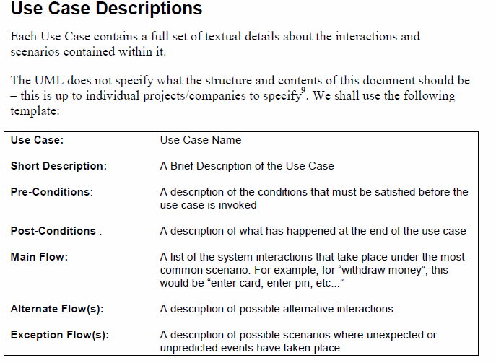

1.2 Class Diagram (aka Conceptual Modeling, Domain Modeling)

1.2.1 Guide Lines for drawing Use Case in Requirements Phase
- No technical terms such as Array, Variable, datatypes or database to be used. These terms could only be used during design phase. Only captured all the terms that the customer’s recognizes.

- Only interested in the attributes of the class (during requirements phase)

- If in doubt whether to put it as an attribute or class. Then to be safe, put as class. For example salary can be an attribute of an employee but also a class.

- If the property of an object cannot do any operation most lightly it will be an attribute

- Steps

  - Draw all classes (don’t link them, don’t give cardinality until this step is done)
  - Do we need inheritance in class diagram during requirements ????
  - Do we need association in class diagram during requirements ????
  - Do we need composite/aggregation in class diagram during requirements ????
  - Link/associate the class(don’t give cardinality until this step is done)/ give role name
  - Give cardinality
  - Write important attributes
  - Class Diagram

On the conceptual model, we aim to capture all of the concepts or ideas that the
customer recognises. For example, some good examples of concepts would be:
 Lift in a lift control system
 Order in a home shopping system
 Footballer in a football transfers system (or a PlayStation football game!)
 Trainer in a stock management system for a shoe shop
 Room in a room booking system
Some very bad examples of concepts are:
 OrderPurgeDaemon the process that regularly deletes old orders from the system
 EventTrigger . the special process that waits for 5 minutes and then tells the
system to wake up and do something
 CustomerDetailsForm . the window that asks for details of the new customer in
a shopping system
 DbArchiveTable . the database table holding a list of all old orders

These are bad concepts, because they are focussing on design . the solution, and not
the problem. In the DbArchiveTable example, we are already tying ourselves down to
a relational database solution. What if it turns out later that it is more efficient,
cheaper, and perfectly acceptable to use a simple text file?

The best rule of thumb here is:
If the customer doesn.t understand the concept, it probably isn.t a concept!
Designers hate the conceptual step . they cannot wait to crack on with design. We
shall see, however, that the conceptual model will slowly transform into a full design
class diagram as we move through the construction phase.

Every association should work like this . when reading the association back in
English, the English sentence should make perfect sense (especially to the customer).
When deciding upon association names, avoid weak names like .has. or .is
associated to. . using such weak language could easily hide problems or errors that
would otherwise have been uncovered if the association name was more meaningful.
DESIGN
- Design Modeling
  - Design Modeling - 1, Design Principles
  - Design Modeling - 2, Software Architecture
  - Design Modeling - 3, Design Activities
  - Design Modeling - 4, Design Deliverables, Artifacts and Process
  - Design Modeling – 5, Design for persistency
  - Design Modeling – 6, Model-driven Architecture
  - Design Modeling – 7, Agility vs. Architecture
- Implementation Model
  - Refactoring
  - Documenting Code
  - Implementing Design Model

Design Modeling - 3, Design Activities

- Typical activities involved when transiting from analysis to design
  - Convert analysis objects to design objects. Done by giving objects more concrete and complete attribute and behaviors
  - Structure to architecture decision
    - Chosen programming language
    - Chosen libraries
    - Chosen persistence model
    - Interfaces to to external system
  - Model details dynamic behavioura
    - Sequence diagram
  - Define object structure
    - Design patterns
    - Review operations, attributes roles and purposes of class – using class diagram
  - No ambiguity

